**[**

**Project Report Template**

**Title of Project:** **Soldier Tracking System (**AI-Based Health Monitoring & Location Tracking)  
**Name of the Innovator:** SHIVASHANKAR IRAPPA CHOUGALA   
**Start Date:** 27-10-2025

**End Date: 31-10-2025**

***Day 1: Empathise & Define***

*Step 1: Understanding the Need*

* Which problem am I trying to solve?

***I’m solving the problem of delayed emergency response and lack of real-time health monitoring for soldiers in remote or combat areas. Soldiers often operate in harsh environments where continuous tracking of their health and location is challenging. My system uses AI-based health monitoring and GPS tracking to provide instant alerts about a soldier’s condition and location, ensuring faster rescue operations and improved safety on the battlefield.***

* Who is affected by this problem?
* How did I find out about this? [Select whichever is applicable]
* Interviews
* Observation
* Online Research
* AI Tools

*Step 2: What is the problem?*

***In critical military missions, soldiers often face life-threatening situations where timely medical assistance and accurate location tracking are difficult. Traditional systems fail to monitor soldiers’ health conditions in real time or pinpoint their exact locations during emergencies. This delay in response can lead to severe injuries or even loss of life. Therefore, there is a strong need for an intelligent system that continuously monitors soldiers’ vital signs and locations, providing immediate alerts to command centers during emergencies.***

Why is this problem important to solve?

***This problem is important to solve because soldiers are the backbone of national security, and their safety is a top priority. In critical missions, even a few seconds of delay in locating or assisting an injured soldier can result in loss of life. By implementing real-time health and location monitoring, the defense forces can respond immediately during emergencies, reducing casualties and improving mission efficiency. Ensuring soldiers’ safety through advanced technology not only boosts their confidence but also strengthens the nation’s defense capabilities.***

**Take-home task**

Ask 2-3 people what they think about the project:

1. **1. Army Veteran:**
2. “This is a great initiative. Many times during missions, it becomes difficult to locate injured soldiers quickly. A system that monitors their health and location in real time can save lives and help the command center take immediate action.”
3. **2. Engineering Student (Electronics):**
4. “The idea is very innovative. Integrating sensors and AI for health monitoring and GPS tracking shows how technology can support defence applications. It’s a great example of using IoT and AI for national security.”
5. **3. Parent of a Soldier:**
6. “As a parent, I always worry about my son’s safety on the border. Knowing that such a system can track his health and location gives me peace of mind. It’s comforting to know that help can reach them faster in emergencies.”

*AI Tools you can use for Step 1 and 2:*

**AI Tools Used:**

1. Meta MGX

• Used as a no-code AI development tool to design and deploy the Soldier Tracking System interface and data workflows.

• Helps integrate sensor data visualization, health status monitoring, and location tracking dashboards without complex coding.

• Ideal for connecting IoT-based inputs (like heart rate, temperature, and GPS data) and displaying them in a user-friendly control panel for real-time monitoring.

1. ChatGPT

• Used for idea generation, documentation writing, and developing logic for AI-based health analysis.

• Helps in designing intelligent alert conditions — for example, detecting abnormal heart rate or temperature patterns and triggering notifications.

• Also assists in report generation, system explanation, and creating communication templates between the device and the command center.

1. AI and IoT Integration References:

To design and enhance the AI-driven monitoring and decision modules, the following tools and frameworks were studied:

• TensorFlow Lite – for understanding on-device health data processing using AI models.

• IBM Watson IoT Platform – for connecting and managing multiple sensor devices securely.

• Google Cloud AI – for analysing and storing real-time data from multiple soldiers.

***Day 2: Ideate***

*Step 3: Brainstorming solutions*

List **at least 5 different solutions** (wild or realistic):

* **Wearable Health Monitoring Device** – A compact device equipped with sensors (heart rate, temperature, and motion) that tracks soldiers’ vital signs in real time.
* **AI-Based Emergency Detection System** – Uses artificial intelligence to detect abnormal health patterns or sudden inactivity and automatically alerts the command center.
* **GPS-Enabled Location Tracker** – Integrates GPS and GSM modules to continuously track the soldier’s position and send updates to the base station.
* **Central Command Dashboard** – A web-based or mobile dashboard displaying soldiers’ live health data and locations, allowing quick decision-making in emergencies.
* **Voice and Message Alert System** – Sends automated voice calls or SMS alerts to higher authorities when a soldier’s vitals cross danger limits or if an accident occurs.
* **Complete Soldier Tracking System** – A full AI + IoT integrated platform that combines real-time health monitoring, GPS tracking, and automated alerts to enhance soldier safety and response speed on the battlefield.

*Step 4: My favourite solution:*

*My favourite solution is the* ***Soldier Tracking System****, an AI-based platform designed to ensure the safety and well-being of soldiers in real time. It combines health monitoring sensors, GPS tracking, and AI-driven alert mechanisms to detect emergencies instantly. The system continuously monitors vital signs such as heart rate, body temperature, and motion, while also tracking the soldier’s location through GPS and GSM modules. Built using* ***Meta MGX*** *and IoT technology, it provides a reliable and easy-to-manage solution that helps command centers respond faster, reducing risks and saving lives during military operations.*

*Step 5: Why am I choosing this solution?*

I am choosing the **Soldier Tracking System** because it integrates **AI-based health monitoring** and **real-time location tracking** into a single, efficient platform. It provides continuous updates on soldiers’ health and position, ensuring timely alerts during emergencies. The system is reliable, easy to operate, and highly effective in enhancing safety during military missions. By enabling faster response and rescue operations, it helps protect soldiers’ lives and strengthens overall mission success.

**AI Tools for Step 3–5**

**1. Meta MGX**

• Used to design and build the Soldier Tracking System project without coding.

• Helps create an interactive prototype combining GPS tracking, health sensor monitoring, and AI-based alert modules.

• Supports integration of IoT and AI logic visually for efficient real-time soldier monitoring.

🔗 Project Link: https://mgx-tpq6y5zhmac.mgx.world

**2. ChatGPT**

• Assisted in brainstorming multiple solution ideas for soldier safety and emergency response.

• Helped write project steps, AI logic explanations, and descriptions for each module (GPS, GSM, sensors, and alerts).

• Used to refine system documentation and generate presentation content in clear, structured language.

**3. AI Chatbot References (for design and flow)**

• Dialog flow – Demonstrates how AI can detect trigger conditions (like abnormal vitals) and respond automatically.

• IBM Watson Assistant – Useful for creating structured alert responses and emergency message templates.

• Microsoft Bot Framework – Shows how AI can connect data inputs (from sensors) to automated alert actions.

**4. AI Research Tools**

• Google Scholar / Research AI – Used for researching existing soldier tracking and health monitoring systems.

• AI Text & Summarization Tools – Helped summarize research papers, optimize technical explanations, and prepare concise reports for Steps 3–5.

**5. AI Tools for Visual Design (Take-Home Task)**

• Canva AI / CoPilot AI / Meta AI – Used to generate and design visuals, flow diagrams, and system mock-ups that represent the Soldier Tracking System’s functionality.

• These tools help in presenting the project attractively for reports, posters, and final submission.

***Day 3: Prototype & Test***

***Step 6: Prototype – Building My First Version***

***What will my solution look like?***

•Home Screen: Welcomes the user (command center or monitoring officer) and provides options to view live soldier data, alerts, and location updates.

• Real-Time Health Monitoring Panel: Displays soldiers’ vital signs such as heart rate, body temperature, and motion activity in a clear dashboard format.

• AI-Powered Alert System: Automatically detects abnormal health readings (like high temperature, low heart rate, or no movement) and sends instant alerts to the control center.

• GPS-Based Location Tracking: Continuously updates the soldier’s real-time location on a digital map, enabling faster rescue or assistance operations.

• Emergency Notification Module: Sends automated SMS or call alerts via GSM when an emergency or abnormal reading is detected.

• Data History & Reports: Stores previous health records and movement history for review and analysis.

***Design Style:***

• Simple, intuitive dashboard layout for easy monitoring by military personnel.

• Dark theme interface with color-coded alert indicators (green – normal, yellow – warning, red – emergency).

• Designed for mobile, tablet, and desktop use to support field and control room operations.

• User-friendly visualization with real-time graphs, icons, and maps for quick understanding.

**Prototype Tools:**

• Built using Meta MGX, a no-code AI development platform that allows integration of IoT data, GPS visualization, and alert logic without coding.

• All modules (sensor data, alerts, and map tracking) are interactive and testable.

• ChatGPT assisted in writing alert logic, report summaries, and communication flow between the soldier unit and control dashboard.

**What AI tools will I need to build this?**

**AI Tools Needed to Build Soldier Tracking System**

1. **Meta MGX**  
   o Used to design and deploy the AI-based Soldier Tracking System without coding.  
   o Helps connect and visualize IoT sensor inputs (heart rate, temperature, motion) with GPS tracking dashboards.  
   o Allows creation of real-time alert conditions and automatic notifications.
2. **ChatGPT (or similar LLMs)**  
   o Used to brainstorm system logic, write alert algorithms, and generate report summaries.  
   o Helps create intelligent conditions for detecting abnormal soldier health data.  
   o Assists in documentation and generating explanation templates for control center alerts.
3. **AI and IoT Integration References**  
   o **TensorFlow Lite / IBM Watson IoT / Google Cloud AI**  
   o Used for understanding on-device data analysis, multi-sensor connection, and secure IoT data transfer.
4. **AI Data Visualization Tools (Optional)**  
   o For plotting live sensor data and GPS tracking using dashboard charts and analytics.  
   o Could use integrated AI analytics in Meta MGX or external APIs for deeper insights.
5. **AI Text & Communication Tools (Optional)**  
   o Used for summarizing soldier health reports and auto-generating alert messages for command centers.

**What AI tools I finally selected to build this solution?**

1. **ChatGPT**
2. **Meta MGX**

**< Build the Innovation >**

**< DASHBOARD OF THE TOOL >**

**Tool Link:** <https://mgx-tpq6y5zhmac.mgx.world>

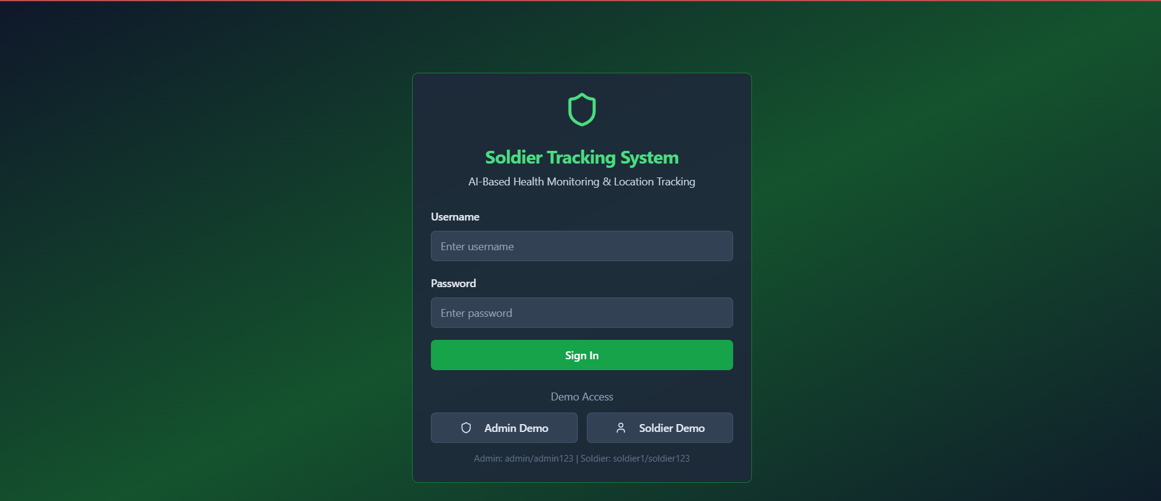

**Dashboard Overview**  
A high-level command center view showing total soldiers, active/critical counts, new alerts, and quick access to Map or Alerts tabs for immediate situational awareness.

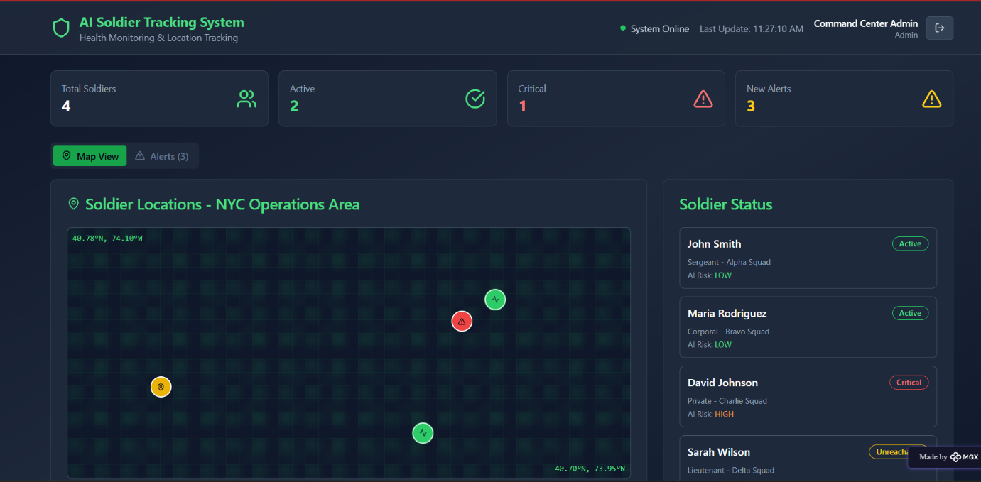

Internal Working of tool:

Individual Soldier Profile :

Detailed single-soldier view showing current vitals (BPM, temperature, SpO₂, BP), AI risk assessment bars, and analysis results for on-the-spot medical decisions.

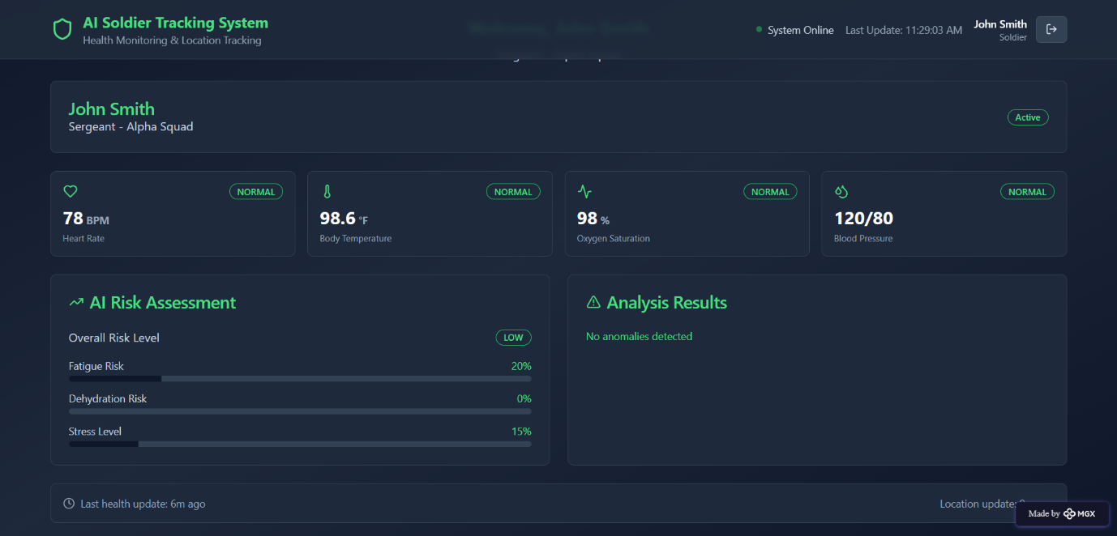

**Live Map (Soldier Locations) :**   
Interactive operation-area map plotting each soldier’s real-time GPS position with color-coded status markers (Active / Critical / Unreachable).

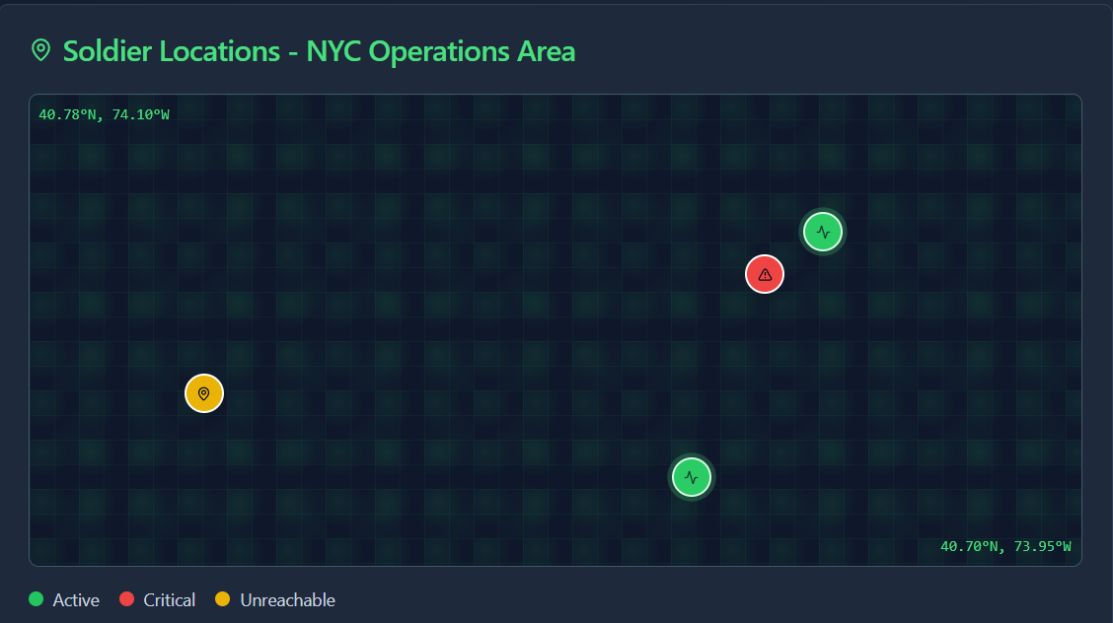

**Soldier Status Panel**  
Compact roster listing soldiers with role, squad, and instant risk badge so officers can quickly scan team health and reachability.

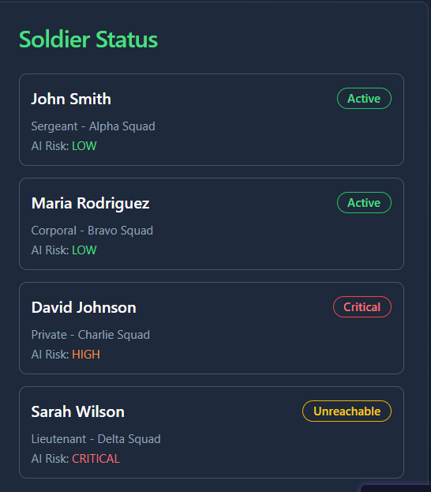

***Step 7: Test – Getting Feedback***

**Who did I share my solution with?**  
I shared my **AI Soldier Tracking System** prototype with:  
• **Engineering students and IoT developers** – to review the system’s technical functionality and sensor integration.  
• **Defense technology enthusiasts and mentors** – to assess how effectively the solution enhances soldier safety.  
• **College faculty members (Electronics & Communication Department)** – for insights on system design, reliability, and data handling.  
• **Peers working on AI-based safety systems** – to get improvement suggestions for user interface and alert accuracy.

**What feedback did I receive?**

**Feedback: Pros and Cons**

**Pros (Positive Insights from Feedback):**

1. The dashboard clearly shows each soldier’s live health data and GPS location, making it easy to monitor.
2. The AI-based alert mechanism was appreciated for its quick detection of critical conditions.
3. The user interface was found modern, organized, and simple to operate for command center use.

**Cons (Areas to Improve Noted in Feedback):**

1. Currently, the prototype displays simulated data; integration with real IoT sensors would make it more practical.
2. Alert sounds or notifications could be added for faster emergency recognition.
3. The system could include a communication link (voice or text) between soldiers and the control unit for better coordination.

**My Response to the Feedback:**  
The **AI Soldier Tracking System** was created using **Meta MGX** as a no-code AI prototyping tool, which limits full real-time IoT and GSM integration. However, the system successfully demonstrates the concept of combining **AI-driven health monitoring**, **location tracking**, and **automated alerts** for military applications. In the next stage, real sensor data (from MAX30102, MLX90614, and GPS modules) will be integrated using ESP32 to achieve full operational capability. The feedback validates the system’s practicality, usefulness, and strong potential to enhance soldier safety and mission efficiency.

👍 What works well:

• **AI-Powered Monitoring:** The system effectively tracks soldiers’ vital health parameters (heart rate, temperature, and motion) in real time using integrated sensors.  
• **Accurate GPS Tracking:** Live location data ensures that every soldier’s position is visible to command units for safety and coordination.  
• **Emergency Alerts:** The AI system can automatically detect unusual conditions (like high temperature or no movement) and trigger alerts instantly.  
• **User-Friendly Dashboard:** The interface is simple, clear, and easy to understand for operators in the control center.  
• **Modular Design:** Each component—health sensors, GPS, GSM—can be independently tested and upgraded without redesigning the entire system.  
• **Scalable Prototype:** Built using **Meta MGX**, the design can be expanded to integrate real hardware (ESP32 + sensors) for field use.  
• **Data Visualization:** Real-time data display makes decision-making faster and improves situational awareness during missions.

👍 **What Needs Improvement**

• **Sensor Integration:** The current prototype uses simulated data; real-time sensor connectivity (MAX30102, MLX90614, accelerometer) should be added.  
• **Alert System:** Needs sound or vibration-based alerts for immediate action during emergencies.  
• **Network Reliability:** Future versions should include redundancy (dual GSM/GPS modules) for continuous connectivity.  
• **User Interaction:** Adding two-way communication between soldiers and the command center would increase safety and coordination.  
• **AI Enhancement:** The AI should learn to predict possible health risks or fatigue levels using previous data trends.  
• **Visual Design Improvements:** More interactive and dynamic UI elements could make the monitoring experience more engaging and intuitive.  
• **Extended Integration:** Collaborations with defense communication systems could make the platform deployment-ready.

***AI Tools you can use for Step 6–7:***

***ChatGPT / Perplexity AI / Claude AI / Canva AI / MetaMGX / Gamma AI / Figma AI:*** *You can use these tools to build prototypes, design interfaces, create content, and visualize the AI-powered monitoring system effectively.*

***Day 4: Showcase***

***Step 8: Presenting My Innovation***

*I am presenting* ***AI-Based Soldier Tracking and Health Monitoring System****, an intelligent platform designed to enhance soldier safety and operational awareness in the field.*

*It features:  
•* ***AI-Powered Health Monitoring:*** *Continuously tracks heart rate, body temperature, and movement using IoT sensors (MAX30102, MLX90614, and accelerometer).  
•* ***Real-Time GPS Tracking:*** *Monitors soldiers’ live locations for better coordination and rapid emergency response.  
•* ***Emergency Alert System:*** *Sends instant notifications via GSM when abnormal conditions or inactivity are detected.  
•* ***User Dashboard:*** *Displays soldier data, health status, and live map tracking on a clean, intuitive interface built in* ***Meta MGX****.  
•* ***AI Decision Support:*** *Uses predictive analysis to identify potential health risks and alert the command center in advance.*

***Impact:*** *This innovation strengthens defense safety by ensuring real-time health and location visibility of soldiers in critical missions. It reduces communication delays, improves life-saving response times, and supports strategic decision-making with AI-driven insights.*

***< SHOWCASE YOUR INNOVATION TO YOUR PEERS >***

***Step 9: Reflections***

***• What did I enjoy the most during this project-based learning activity?*** *I enjoyed designing a real-time soldier tracking interface and integrating AI-based health monitoring using a no-code tool. It was rewarding to see the prototype come alive on Meta MGX and simulate how technology can save lives in critical defense missions.*

***• What was my biggest challenge during this project-based learning activity?*** *My biggest challenge was connecting multiple features—GPS, GSM, and sensor monitoring—within the prototype while keeping the interface simple and functional. Balancing technical complexity with usability required multiple design iterations and careful AI logic setup.*

* ***Take-Home Task:*** *🔗* https://github.com/shivashankar1911/AI-Based-Soldier-Tracking-and-Health-Monitoring-System

***AI Tools you can use for Step 8:***

***Canva AI:*** *Use this tool to design your presentation or pitch document visually.  
You can then* ***download it as a PDF*** *and upload it to* ***GitHub*** *as part of your final submission.*